2019-2020 EDUCATION AND TEACHING YEAR MUSTAFAKEMALPASA SECONDARY
SCHOOL 8TH CLASSES, ELECTIVE ENGLISH LESSON, 1ST TERM 2ND WRITTEN EXAM
(BEP SINAVI)

Name-Surname: ……………….…………….…………….. Class:8 /.….. Number: …… POINT:___

A-Match the words with their Turkish meanings. (3x10=30 P)
(Verilen kelimeleri Türkçe karşılıklarıyla eşleştiriniz.)
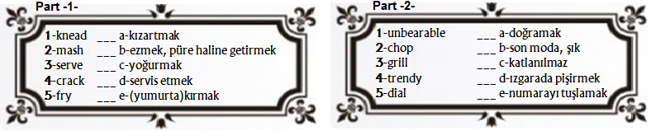

B-Put the sentences into correct order. (Cümleleri oluş sırasına göre sıralandırınız)(3 x 4 = 12 P)

(____) Finally, cook it for 5 minutes. Enjoy your meal!

(____) Next, mix them.

(____) First,crack the eggs into a bowl

( 3 ) After that, put the mixture into a pan.

C-Circle the correct one. (Doğru seçeneği işaretleyiniz) (3x5=15 P)

1-He is not available right now. Would you like to ___________ a message?
- speak B) leave

2-I prefer pop music ____ rock music. It is very exciting.
- from B) to

3-Alice : How often do you watch TV?
David : ………………. .
- Always B) I surf on the net.

4-Tina : What do you do in the evenings?
John : ………………. .
- I watch TV and read a book. B) I am helpful and generous.
5-I can’t eat this soup. Because it is very ……………. .
- tasty B) salty

D-Write the words under the correct picture. (Kelimeleri doğru resmin altına yazınız) (3x5=15 P)

[bored] [angry] [accept] [bad line] [torch]

1-……………………… | 2-……………………… | 3-……………………… | 4-……………………… | 5-………………………

E-Fill in the blanks with “before” or “after” (4 x 3 = 12 P)
(Boşlukları anlamlı olacak şekilde “before” ya da “after” ile tamamlayınız)
You should study hard your exams.
Brush your teeth you go to bed.
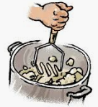 Mash the potatoes you boil them for 30 minutes..

E-Circle the correct one. (4 x 4 = 16 P)
(Doğru seçeneği işaretleyiniz)
1-Choose correct title. (Tabloya uygun başlığı işaretleyiniz)

2-You’re having a phone call with your friend, but you couldn’t hear his last sentence well.
What do you say?
A) I can understand you. B) It’s a bad line, I guess. Can you say that again?
C) Sorry, but I’m not available at the moment. D) Can I take your name?

3-Kevin and Justin want to read a book and talk about it later. Here are the lists of their personal interests:
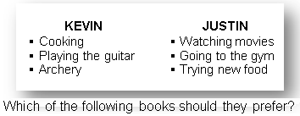
A) OUTDOOR SPORTS B) HISTORY OF MUSIC
C) TRADITIONAL DISHES D) HOW TO LOOK FIT
4- Tom: How often do you play online games?
Jack: I can’t stand playing computer games because I think they are ……………… .
A) impressive B) interesting C) exciting D) ridiculous

*Puanlama her bölümde belirtilmiştir.
*Belirtilen puanlama verilen her doğru cevap içindir.

