|  |  |  |  |
| --- | --- | --- | --- |
| **T.C. NARLIDERE CAHİDE AHMET DALYANOĞLU ANADOLU LİSESİ**  **2018-2019 EĞİTİM-ÖĞRETİM YILI**  **İNGİLİZCE DERSİ 1. DÖNEM 2. ORTAK YAZILI SINAVI** | | | |
| **Adı – Soyadı** |  | **Sınav Tarihi** | **28.12.2018** |
| **Sınıfı** | **12 / ......** | **Ders Öğretmeni** |  |
| **Okul No** |  | **ALDIĞI PUAN** |  |

1. **Read the dialogue below and answer the questions.** (5 x 4p = 20p)

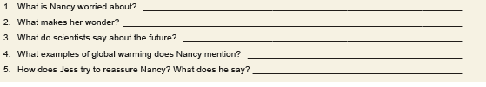

1. **Fill in the blanks with “** will **/** won’t **”.** (4 x 3p = 12p)



1. **Create answers using the words given in the brackets.** (3 x 5p = 15p)



**turn the page. you still have some questions...** ☹ 🡪

1. **Fill in the blanks with “** will **/** won’t” **or** “be going to**”.** (4 x 3p = 12p)



1. **Match !!!** (7 x 3p = 21p)



1. **Writ the suitable adjectives into the blanks.** (7 x 3p = 21p)

**sleepy / shocked / confused / happy / upset / bossy / dizzy**



|  |  |  |  |
| --- | --- | --- | --- |
| **Duration** | **40 minutes** | **Total score** | **100** |
| **Attention** | In accordance with the related official discipline regulations, acts of cheating or allowing others to duplicate your answers are strictly prohibited. | | |
| **Narlı Mah. Metin Oktay Sokak No: 17, 35330 Narlıdere / İZMİR || (232) 2391926 - (232) 2392926 || http://narliderecadal.meb.k12.tr** | | | |